# Acceptance Criteria Testing

## Story ID 10

User Story: As a customer shipping a package I want to be able to print consignment notes so that the driver can quickly identify and deliver the package after being processed at the warehouse.

* After booking a package I can generate a PDF consignment note and print it with all the details filled in.

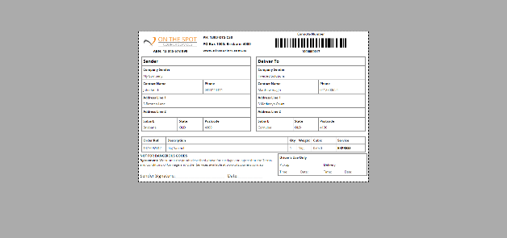

Jeff Jefferson is gone

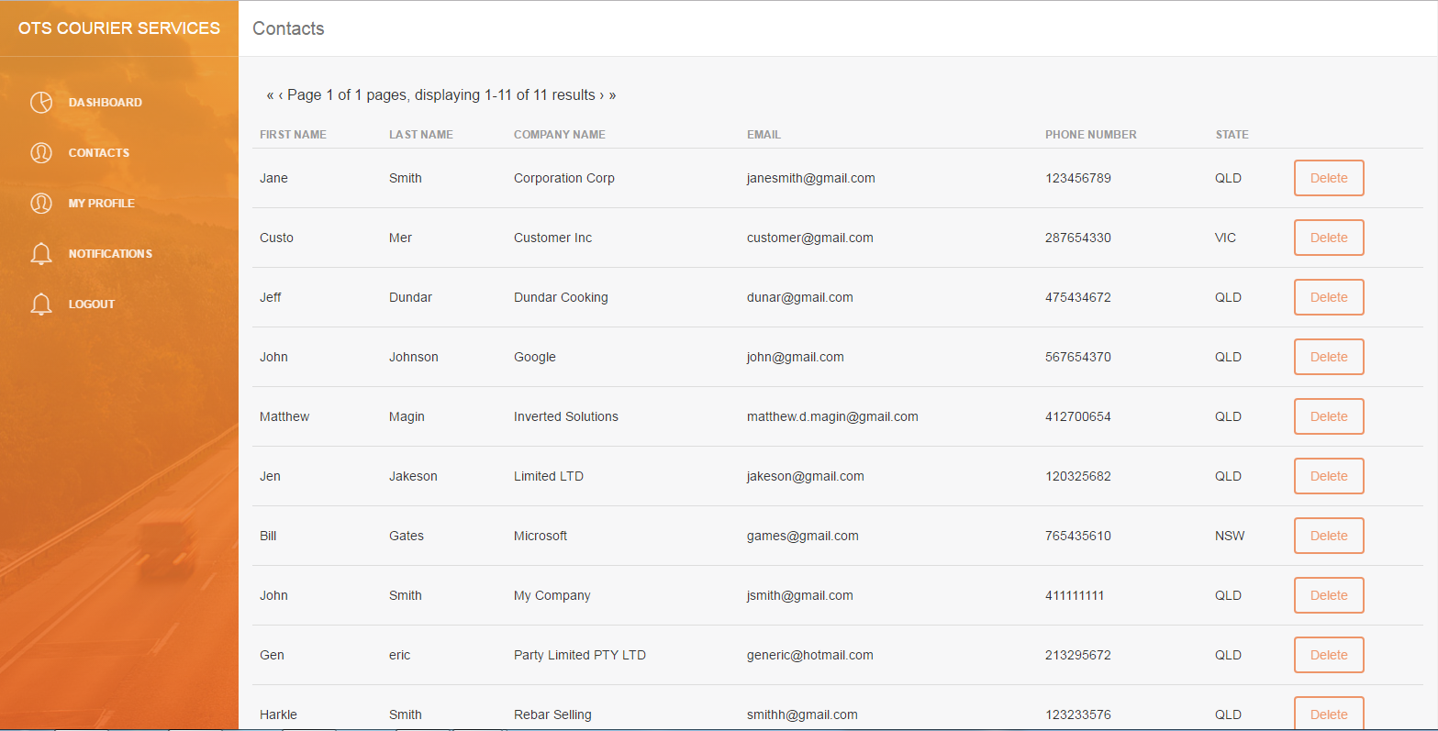

NOT IMPLEMENTED → ADD CONTACT

During development, it was found since the current iteration of the contacts page draws from the customers table and adding a contact would effectively create an account for them (complete with a password) either this function needs to be available to the customers themselves or be retooled to use a different table.